NAME:…………………………………………………………………………………………..
RWENTOJO LOWER SECONDARY EDUCATION EXAMINATIONS
PHYSICS
SENIOR TWO
END OF YEAR 2022
2 Hours 15 Minutes
SECTION A
Instructions: Attempt all questions in this section

SECTION A
Attempt all questions.
- Energy is difficult to visualize. You cannot pick it up or touch it because it has no mass; neither does it occupy space. Instead of defining energy in terms of what it is, energy is defined in terms of what it does or can do. Energy is also classified according to it’s forms.

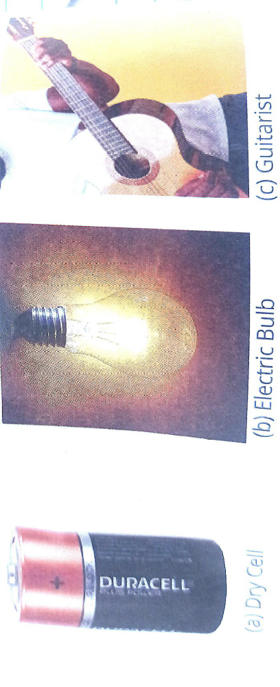
- List the forms of energy shown in figure above(a)-(c) (3 marks)
………………………………………………………………………………………………………………………………………………………………………………………………………………………………………………………………………………………………………………………………………………………………………………………………………………………………………………………….
- List other forms of energy that you use in your day to day life. (3 marks)
…………………………………………………………………………………………………………………………………………………………………………………………………………………………………………………………………………………………………………………………………………………………………………………………………………………………………………………………………………………………………………………………………………………………………………………………………………………..
- A brick of mass 3.0kg and dimensions 5.0cm x 3.0cm x 2.0cm rests on different sides on the laboratory table. Calculate the
(a)Maximum pressure (02 marks)
……………………………………………………………………………………………………………
……………………………………………………………………………………………………………
……………………………………………………………………………………………………………
……………………………………………………………………………………………………………
……………………………………………………………………………………………………………
……………………………………………………………………………………………………………
……………………………………………………………………………………………………………
……………………………………………………………………………………………………………
……………………………………………………………………………………………………….….

b) Minimum pressure (02marks)
……………………………………………………………..………………………
……………………………………………………………..……………………………………………………………………………………………………………
………………………………………………………………………………………………………………………………………………………………………………………………………………………………………………………………………………………………………………………………………………………………………………………………………………………………………………………………………………………………………………………………
- (a)State Pascal’s principle (02 mark)
…………………………………………………………………………………………………………………………………………………………………………………………………………………………………………………………………………………………………………………….…………..
(b) Identify devices that apply Pascal’s law of transmission of pressure in liquids. (03marks)
…………………………………………………………………………………………………………………………………………………………………………………………………………………………………………………………………………………………………………………………………………………………………………………………………………………………………………………………………………………………………………………………………………………………………
- (a) Distinguish between potential and kinetic energy. (2 marks)
……………………………………………………………………………………………………………………………………………………………………………………………………………………………………………………………………………………………………………………………………………………………………………………………………………………………………………………………..
(b) Discuss the energy changes that take place in the bulb and loud speaker. (4 marks)
………………………………………………………………………………………………………………………………………………………………………………………………………………………………………………………………………………………………………………………………………………………………………………………………………………………………………………………………

- As the pendulum bob swings to and from, it’s height above the tabletop is constantly changing. As the height decreases, potential energy is being lost; and simultaneously, the kinetic energy is being gained. Yet at all times, the sum of potential and kinetic energies of the bob remains constant at a point as shown.
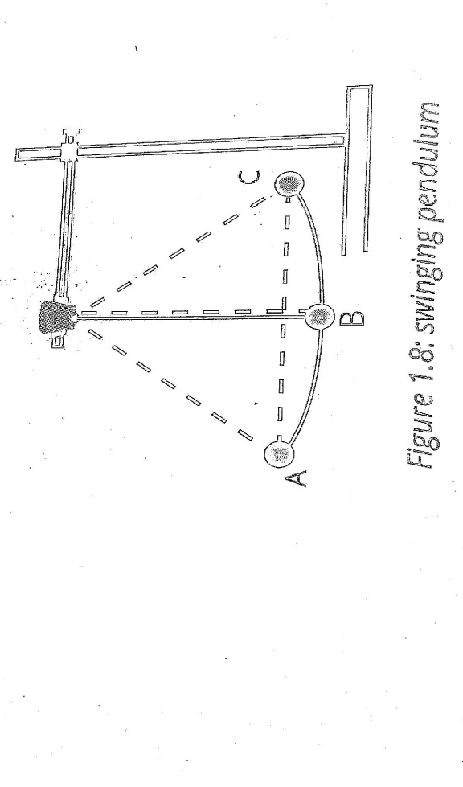

At what point does the bob attain: (4 marks)
- Maximum potential energy
……………………………………………………………………………………………………………………..
- Maximum kinetic energy
………………………………………………………………………………………………………………………
- Momentarily stops moving
………………………………………………………………………………………………………………………..
- The highest speed?
………………………………………………………………………………………………………………………..

6. (a)What is meant by the following terms
(i)Proton (1 mark)
…………………………………………………………………………………………………………………………………………………………………………………………………………………………………………………………………………………………………………………………
(ii)Electrons (1 mark)
…………………………………………………………………………………………………………………………………………………………………………………………………………………………………………………………………………………………………………………………
(iii) Neutron (1 mark)
……………………………………………………………………………………………………………………………………………………………………………………………………………………………………………………………………………………………………………………………………
(b) state the law of electrostatics. (1 mark)
……………………………………………………………………………………………………………………………………………………………………………………………………………………………………………………………………………………………………………………………………
(c) How can a neutral body be charged by induction? (3 marks)
…………………………………………………………………………………………………………………………………………………………………………………………………………………………………………………………………………………………………………………………………………………………………………………………………………………………………………………………………………………………………………………………………………………………………………………………………………………………………………………………………………
(d) give one use of a gold leaf electroscope. (1 mark)
………………………………………………………………………………………………………………………………………………………………
(e) define lightening and state an instrument used to protect buildings from lightening. (2 marks)
………………………………………………………………………………………………………………………………………………………………………………………………………………………………………………………………………………………………………………………………….
7. Define the following terms as applied to curved mirrors;
- Pole……………………………………………………………………………………………………………………………………
- Centre of curvature……………………………………………………………………………………………………………………………..
- Radius of curvature……………………………………………………………………………………………………………………………………………………………………..
- Focal length……………………………………………………………………………………………………………………………………………………………………………….
Use a ray diagram to show the formation of an image for an object placed between C and principal focus F. (4marks)
…………………………………………………………………………………………………………………………………………………………………………………………………………………………………………………………………………………………………………………………………………………………………………………………………………………………………………………………………………………………………………….
An object of height 5 cm is placed 10 cm in front of a concave mirror of focal length 15 cm. using graphical contruction method, determine the position, size and nature of the image formed. (7 marks)

